LEX PROGRAMS : 21 – 40
Exp. No. 21 Write a LEX specification file to take input C program from a .c file and count the number of characters, number of lines & number of words.
%{
#include <stdio.h>
extern FILE *yyin;
int nchar = 0, nline = 0, nword = 0;
%}
%%
\n { nline++; nchar++; }
[^ \t\n]+ { nword++; nchar += yyleng; }
. { nchar++; }
%%
int yywrap(void){
return 1;
}
int main(int argc, char *argv[]){
if(argc < 2){
printf("Usage: %s <inputfile>\n", argv[0]);
return 1;
}
yyin = fopen(argv[1], "r");
yylex();
printf("characters: %d\n", nchar);
printf("lines : %d\n", nline);
printf("words : %d\n", nword);
fclose(yyin);
return 0;
}

Input C program Output
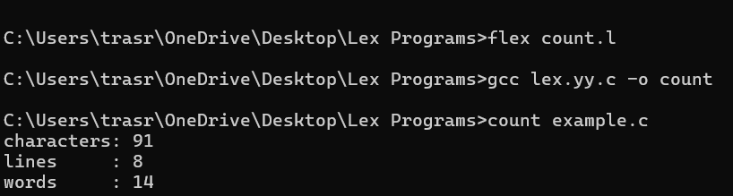
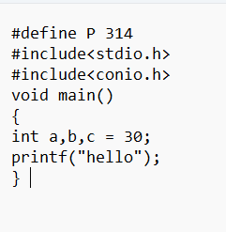

Exp. No. 22 Write a LEX program to print all the constants in the given C source program file.
%{
#include<stdio.h>
int cons=0;
extern FILE *yyin;
%}
digit [0-9]+
%%
{digit} {
cons++;
printf("found :%s", yytext);
}
.|\n {}
%%
int yywrap(void){
return 1;
}
int main(int argc, char *argv[]){
yyin=fopen(argv[1], "r");
yylex();
printf("constants count:%d", cons);
fclose(yyin);
return 0;
}
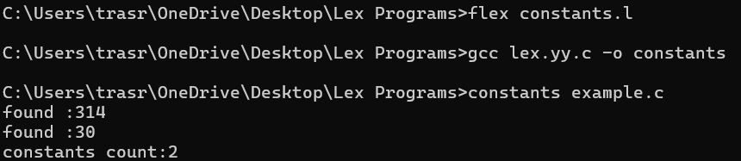
Input C program OUTPUT

Exp. No. 23 Write a LEX program to count the number of Macros defined and header files included in the C program.
%{
#include <stdio.h>
extern FILE *yyin;
int nmacro = 0, nheader = 0;
%}
%%
#define { nmacro++; }
#include { nheader++; }
.|\n { }
%%
int yywrap() { return 1; }
int main(int argc, char *argv[]) {
yyin = fopen(argv[1], "r");
yylex();
printf("macro count : %d\n", nmacro);
printf("header count : %d\n", nheader);
fclose(yyin);
return 0;
}
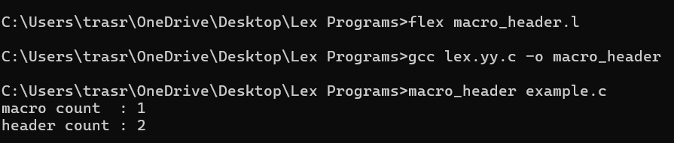
Input C program OUTPUT

Exp. No. 24 Write a LEX program to print all HTML tags in the input file.
%{
#include<stdio.h>
extern FILE *yyin;
int tags = 0;
%}
%%
"<"[^>]*">" {
tags++;
printf("%s\n", yytext);
}
.|\n { }
%%
int yywrap(void) { return 1; }
int main(int argc, char *argv[]){
yyin=fopen(argv[1], "r");
yylex();
printf("\nNumber of HTML tags: %d\n", tags);
fclose(yyin);
return 0;
}
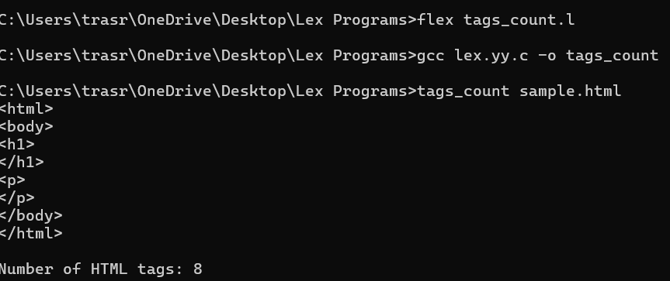
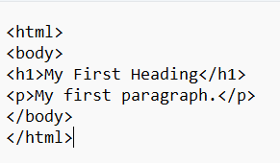
Input html code OUTPUT

Exp. No. 25 Write a LEX program which adds line numbers to the given C program file and display the same in the standard output.
%{
#include <stdio.h>
int linenumb=0;
extern FILE *yyin;
%}
%%
^(.*)\n {printf("%d\t %s",++linenumb,yytext);}
. {}
%%
int yywrap(void){
return 1;
}
int main(int argc, char *argv[]){
yyin=fopen(argv[1],"r");
yylex();
fclose(yyin);
return 0;
}
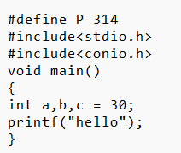
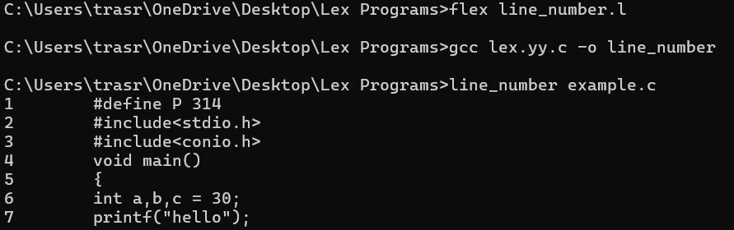
Input C code OUTPUT

26. Write a LEX program to count the number of comment lines in a given
C program and eliminate them and write into another file.
%{
#include <stdio.h>
int comment_lines = 0;
%}
%%
//.* { comment_lines++; }
"/*"([^*]|\*+[^/])*"*/" {
int lines = 1;
for (int i = 0; yytext[i]; i++)
if (yytext[i] == '\n') lines++;
comment_lines += lines;
}
. { ECHO; }
\n { ECHO; }
%%
int yywrap() { return 1; }
int main()
{
yylex();
printf("\nTotal Comment Lines = %d\n", comment_lines);
return 0;
}INPUT :
#include<stdio.h>
int main()
{
int a,b,c; /*varible declaration*/
printf(“enter two numbers”);
scanf(“%d %d”,&a,&b);
c=a+b;//adding two numbers
printf(“sum is %d”,c);
return 0;
}

27. Write a LEX program to identify the capital words from the given input.
%%
[A-Z]+[\t\n ] { printf("Capital Word : %s\n",yytext); }
. ;
%%
int main( )
{
printf("Enter String :\n");
yylex();
}
int yywrap( )
{
return 1;
}
INPUT :
CAPITAL of INDIA is DELHI
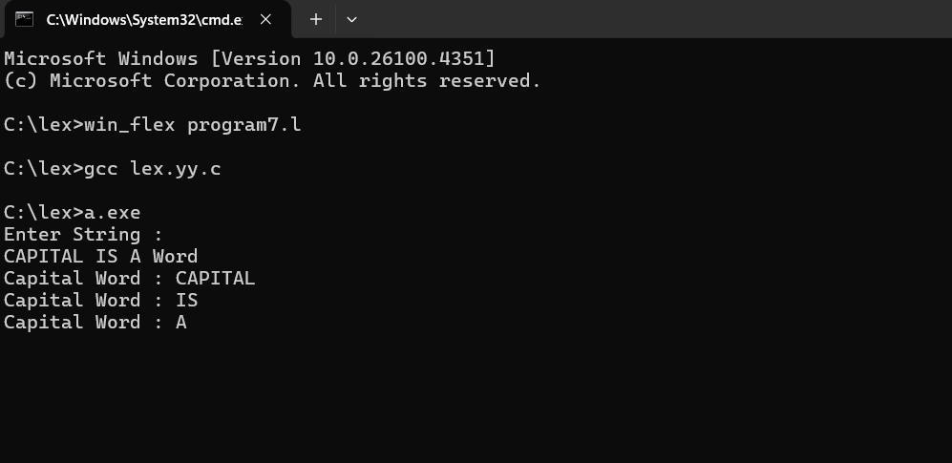

28. Write a LEX Program to check the email address is valid or not.
%{
#include <stdio.h>
int valid = 0;
%}
%%
[A-Za-z0-9]+@[A-Za-z]+\.[A-Za-z]+ { valid = 1; }
.* ;
%%
int yywrap() { return 1; }
int main()
{
printf("Enter email: ");
yylex();

if (valid)
printf("\nValid Email\n");
else
printf("\nInvalid Email\n");

return 0;
}
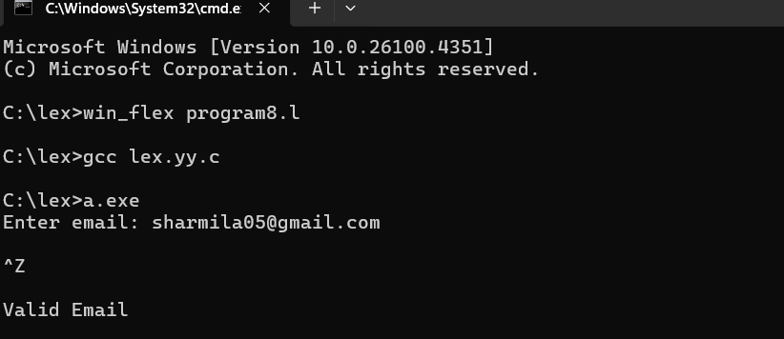
29. Write a LEX Program to convert the substring abc to ABC from the given
input string
%{
#include <stdio.h>
%}
%%
abc { printf("ABC"); }
. { ECHO; }
\n { ECHO; }
%%
int main() {
yylex();
return 0;
}
int yywrap() { return 1; }
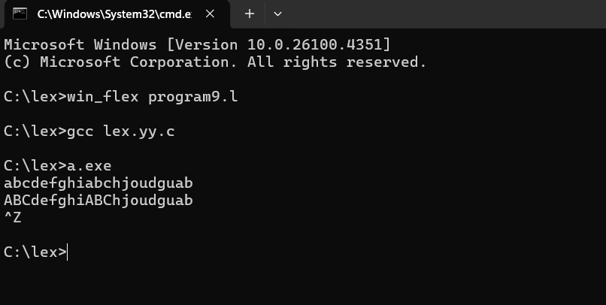
30. Implement a LEX program to check whether the mobile number is valid
or not.
%{
#include <stdio.h>
%}
%%
[1-9][0-9]{9} {printf("\nMobile Number Valid\n");}
.* {printf("\nMobile Number Invalid\n");}
%%
int main()
{
printf("\nEnter Mobile Number : ");
yylex();
printf("\n");
return 0;
}
int yywrap()
{ return 1; }
31. Implement Lexical Analyzer using FLEX (Fast Lexical Analyzer). The
program should separate the tokens in the given C program and display
with appropriate caption.
%{
#include <stdio.h>
#include <string.h>

int kcount = 0, icount = 0;

char *kw[] = {"int","void","include","main","printf"};
int iskw(char *w){
for(int i=0;i<5;i++)
if(!strcmp(w, kw[i])) return 1;
return 0;
}
%}

%%

"#include"<[^>]+> {
printf("include is a keyword\n");
/* print whatever is inside <> */
for(int i=10;i<yyleng-1;i++) putchar(yytext[i]);
printf(" is a standard library\n");
}

\"[^\"]*\" { printf("%s is a string literal\n", yytext); }

[0-9]+ { printf("%s is a number\n", yytext); }

[a-zA-Z_][a-zA-Z0-9_]* {
if(iskw(yytext)) {
printf("%s is a keyword\n", yytext);
kcount++;
} else {
printf("%s is a identifier\n", yytext);
icount++;
}
}

. ; /* ignore all else */

%%

int main(int c, char *v[]){
if(c>1) yyin = fopen(v[1], "r");
yylex();
printf("number of identifiers = %d\n", icount);
printf("number of keywords = %d\n", kcount);
return 0;
}
int yywrap(){ return 1; }

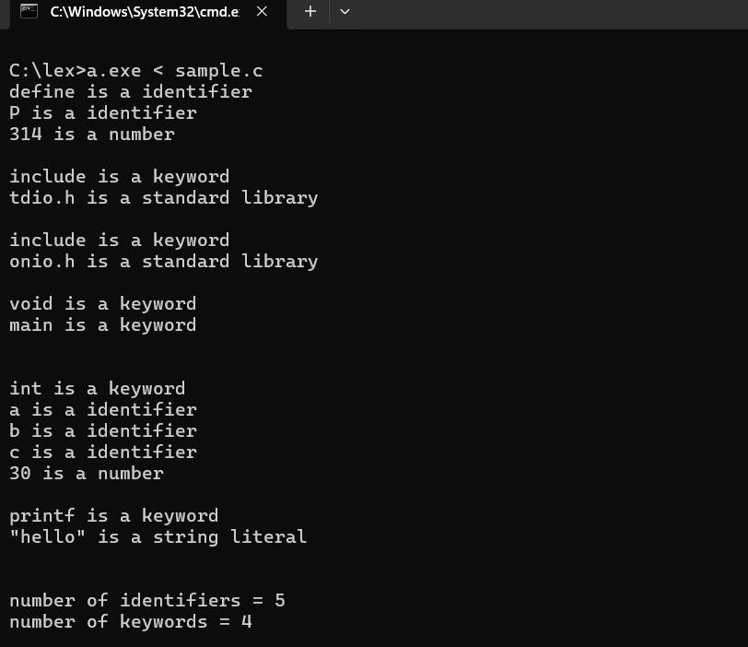
32. Write a LEX program to count the number of vowels in the given
sentence.
%{
int vow_count=0;
int const_count =0;
%}
%%
[aeiouAEIOU] {vow_count++;}
[a-zA-Z] {const_count++;}
%%
int yywrap(){}
int main()
{
printf("Enter the string of vowels and consonants:");
yylex();
printf("Number of vowels are: %d\n", vow_count);
printf("Number of consonants are: %d\n", const_count);
return 0;
}
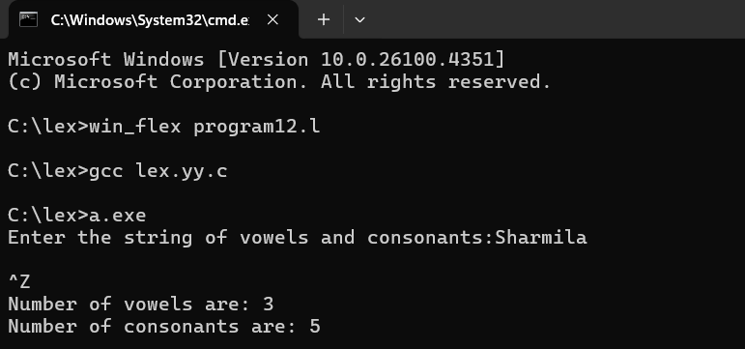
33. Write a LEX program to separate the keywords and identifiers.
%{
#include <stdio.h>
#include <string.h>

int kcount = 0, icount = 0;

char *kw[] = {"int","void","include","main","printf"};
int iskw(char *w){
for(int i=0;i<5;i++)
if(!strcmp(w, kw[i])) return 1;
return 0;
}
%}

%%

"#include"<[^>]+> {
printf("include is a keyword\n");
/* print whatever is inside <> */
for(int i=10;i<yyleng-1;i++) putchar(yytext[i]);
printf(" is a standard library\n");
}

\"[^\"]*\" { printf("%s is a string literal\n", yytext); }

[0-9]+ { printf("%s is a number\n", yytext); }

[a-zA-Z_][a-zA-Z0-9_]* {
if(iskw(yytext)) {
printf("%s is a keyword\n", yytext);
kcount++;
} else {
printf("%s is a identifier\n", yytext);
icount++;
}
}

. ; /* ignore all else */

%%

int main(int c, char *v[]){
if(c>1) yyin = fopen(v[1], "r");
yylex();
printf("number of identifiers = %d\n", icount);
printf("number of keywords = %d\n", kcount);
return 0;
}
int yywrap(){ return 1; }
34. Write a LEX program to recognise numbers and words in a statement.
%{
#include <stdio.h>
%}
%%
[0-9]+ { printf("%s is a NUMBER\n", yytext); }
[a-zA-Z]+ { printf("%s is a WORD\n", yytext); }
[ \t\n] ; /* ignore spaces */
. ; /* ignore other characters */
%%
int main() {
yylex();
return 0;
}
int yywrap() {
return 1;
}
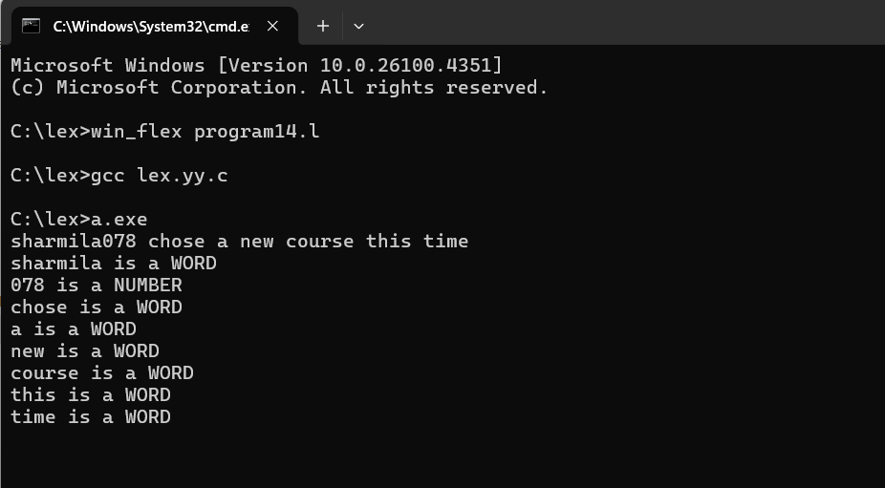
35. Write a LEX program to identify and count positive and negative
numbers.
%{
#include <stdio.h>
int posCount = 0;
int negCount = 0;
%}
%%
[-][0-9]+ { printf("%s is NEGATIVE number\n", yytext); negCount++; }
[0-9]+ { printf("%s is POSITIVE number\n", yytext); posCount++; }
[ \t\n]+ ; /* Ignore spaces, tabs, newlines */
. ; /* Ignore any other character */
%%
int main()
{
printf("Enter numbers: ");
yylex();
printf("\nTotal Positive Numbers = %d\n", posCount);
printf("Total Negative Numbers = %d\n", negCount);
return 0;
}
int yywrap()
{
return 1;
}
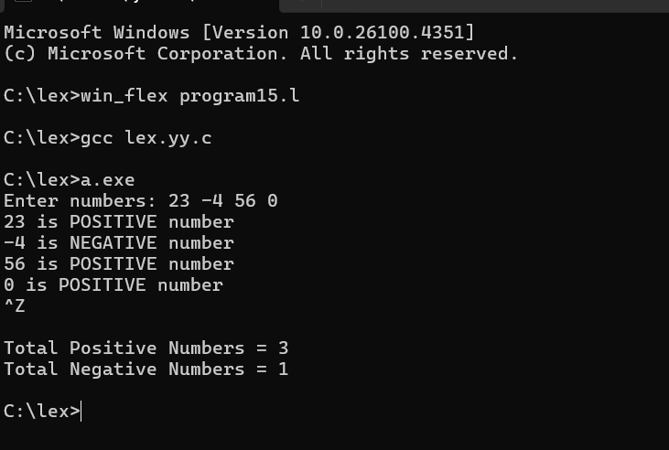
36. Write a LEX program to validate the URL.
%%
((http)|(ftp))s?:\/\/[a-zA-Z0-9](.[a-z])+(.[a-zA-Z0-9+=?]*)* {printf("\nURL Valid\n");}
.+ {printf("\nURL Invalid\n");}
%%
void main()
{
printf("\nEnter URL : ");
yylex();
printf("\n");
}
int yywrap()
{
}
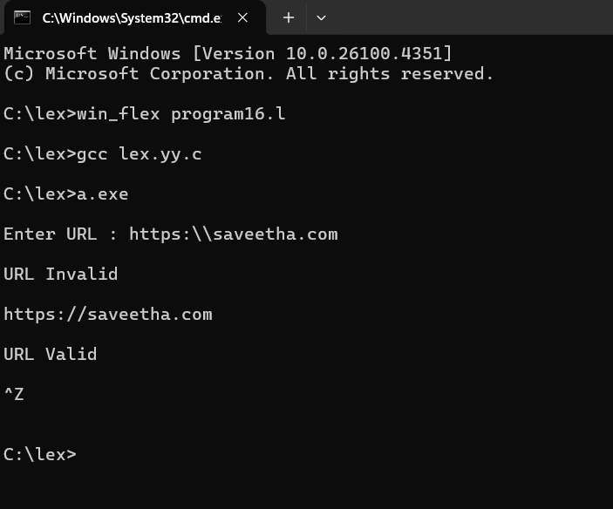
37. Write a LEX program to validate DOB of students.
%%
((0[1-9])|([1-2][0-9])|(3[0-1]))\/((0[1-9])|(1[0-2]))\/(19[0-9]{2}|2[0-9]{3}) printf("Valid DoB");
.* printf("Invalid DoB");
%%
int main()
{
yylex();
return 0;
}
int yywrap()
{return 1;}
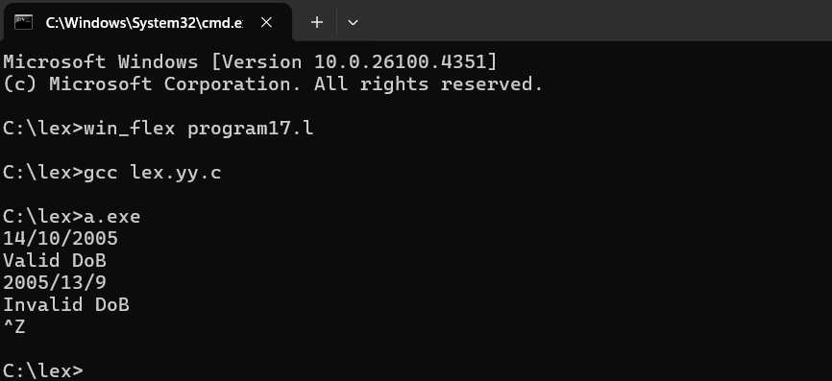
38. Write a LEX program to check whether the given input is digit or no
%%
[0-9]+ {printf("\nValid digit \n");}
.* printf("\nInvalid digit\n");
%%
int yywrap(){}
int main()
{
yylex();
return 0;
}
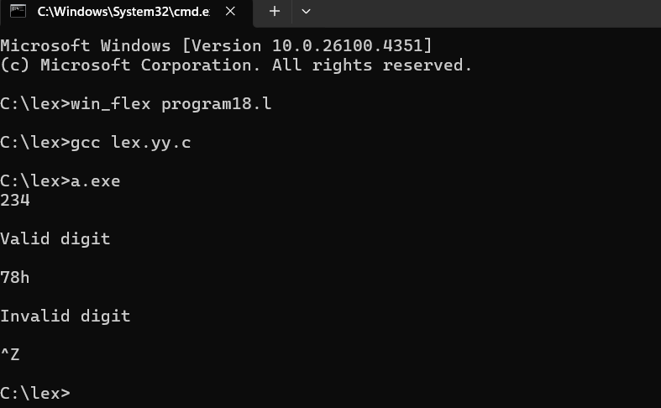

39. Write a LEX program to implement basic mathematical operations.
%{
#include <stdio.h>
#include <stdlib.h>

int num1 = 0, num2 = 0;
char op = 0;
%}

%%

[0-9]+ {
if (num1 == 0)
num1 = atoi(yytext);
else
num2 = atoi(yytext);
}

[\+\-\*/] { op = yytext[0]; }

[ \t\n]+ ; /* ignore whitespace */

. ; /* ignore any other character */

%%

int main() {
printf("Enter expression (like 12 + 5): ");
yylex();

switch(op) {
case '+': printf("Result = %d\n", num1 + num2); break;
case '-': printf("Result = %d\n", num1 - num2); break;
case '*': printf("Result = %d\n", num1 * num2); break;
case '/':
if(num2 != 0)
printf("Result = %d\n", num1 / num2);
else
printf("Division by zero error!\n");
break;
default: printf("No valid operator found!\n");
}

return 0;
}

int yywrap() { return 1; }
